Day75 - Task36 - Terraform(Final)

Create VPC, Create Internet gateway, Create Custom Route Table, Create Subnet, Now associate subnet with Route Table then create Security Group to allow port 22.80,443, Create a network interface with an ip in the subnet that was created in step 4, Assign an elastic IP to the network interface created in step 7, Create Ubuntu server and install/enable apache2

Step 1:Provider
A provider tells Terraform which cloud/platform to communicate with.
Here:
Terraform
|
↓
AWS Provider
|
↓
AWS
And:
region = "eu-north-1"
means:
Create the AWS resources in the eu-north-1 region.
This is the AWS Stockholm region.
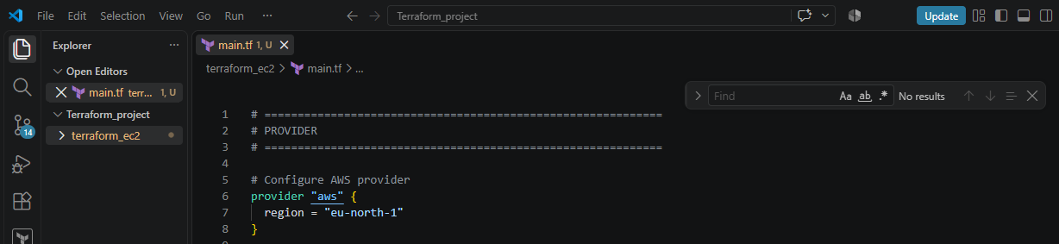
Step 2: Create VPC
Code:
resource "aws_vpc" "main" {
cidr_block = "10.0.0.0/16"

tags = {
Name = "my-vpc"
}
}
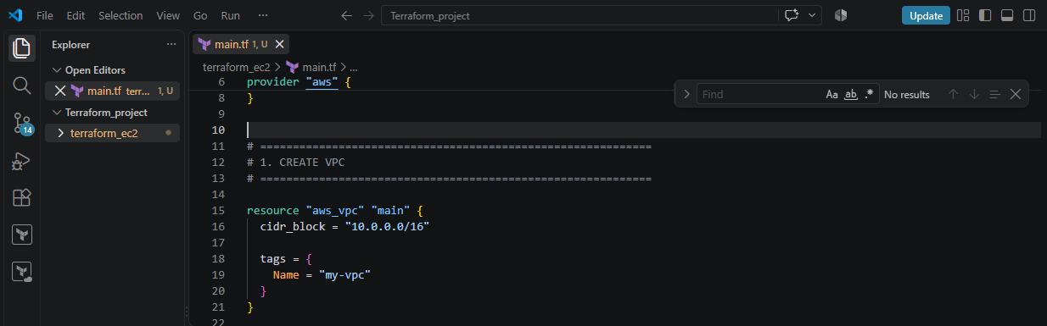
We are creating our own private network inside AWS.
We are creating:
VPC
10.0.0.0/16
The /16 gives you a large private IP range.
10.0.0.0
↓
10.0.0.1
10.0.0.2
10.0.0.3
...
Terraform syntax
resource "aws_vpc" "main"
means:
resource type = aws_vpc
resource name = main
Therefore, Terraform refers to this VPC as:
aws_vpc.main

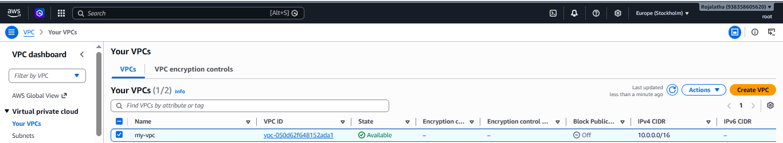

Step 3: Internet Gateway
Code:
resource "aws_internet_gateway" "igw" {
vpc_id = aws_vpc.main.id

tags = {
Name = "my-internet-gateway"
}
}

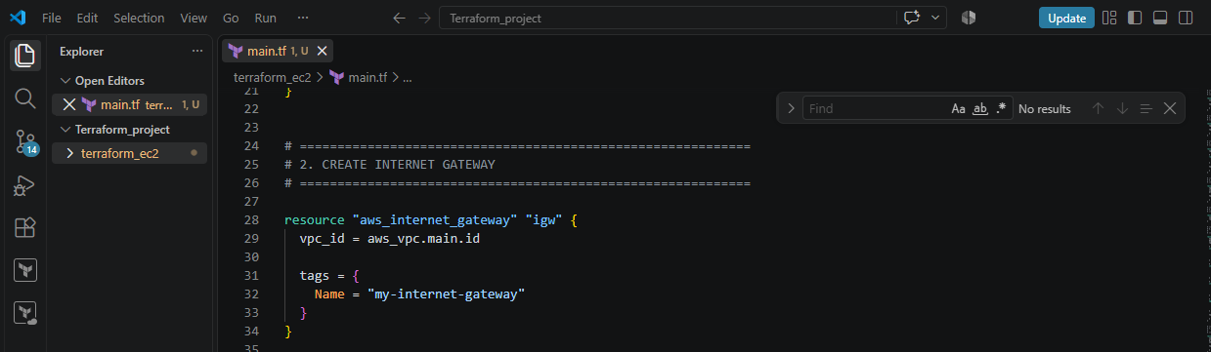
An Internet Gateway (IGW) allows communication between your VPC and the internet.
Think of it as a door from your VPC to the internet.
VPC
|
|
Internet Gateway
|
|
Internet
Notice this:
vpc_id = aws_vpc.main.id
This means:
Attach the Internet Gateway to the VPC that Terraform created above.
Terraform automatically knows the VPC ID after creating it.
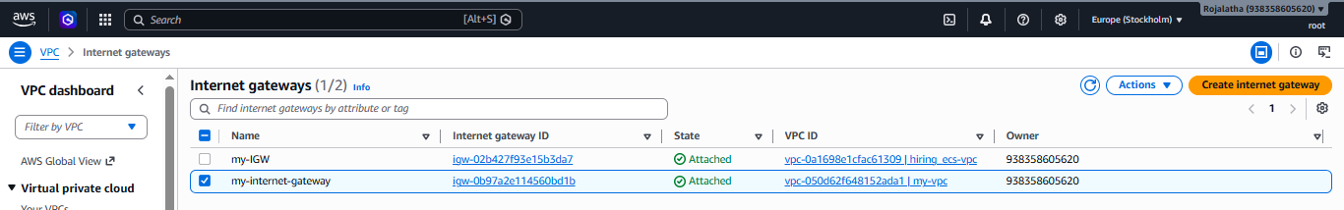

Step 4: Route Table
Code:
resource "aws_route_table" "public" {
vpc_id = aws_vpc.main.id

route {
cidr_block = "0.0.0.0/0"
gateway_id = aws_internet_gateway.igw.id
}

tags = {
Name = "my-public-route-table"
}
}

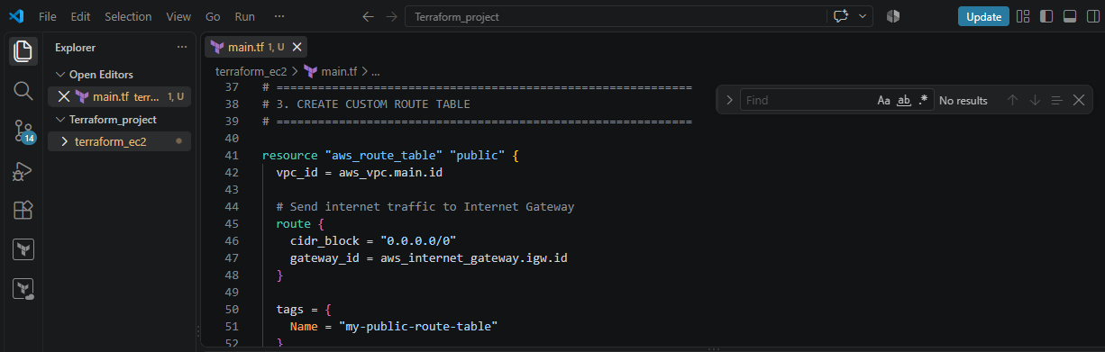
This is very important.
A route table tells AWS where network traffic should go.
You have:
cidr_block = "0.0.0.0/0"
This means:
Any destination that isn't otherwise specifically matched.
In simple words:
Internet traffic
↓
0.0.0.0/0
↓
Internet Gateway
And:
gateway_id = aws_internet_gateway.igw.id
means:
Send that traffic through the Internet Gateway.
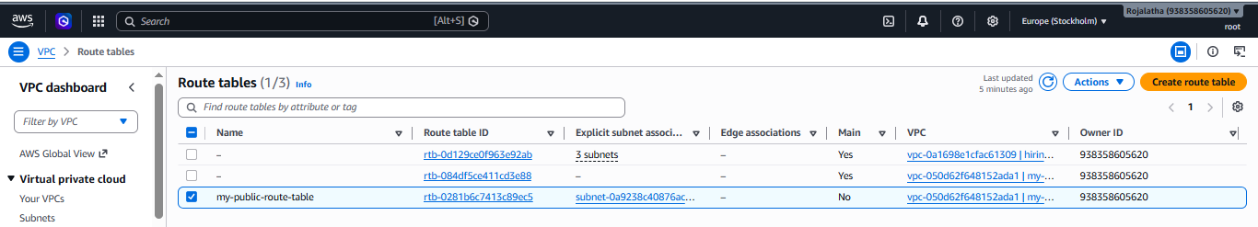

Step 5: Create Subnet
Code:
resource "aws_subnet" "public" {
vpc_id = aws_vpc.main.id
cidr_block = "10.0.1.0/24"
availability_zone = "eu-north-1a"

tags = {
Name = "my-public-subnet"
}
}

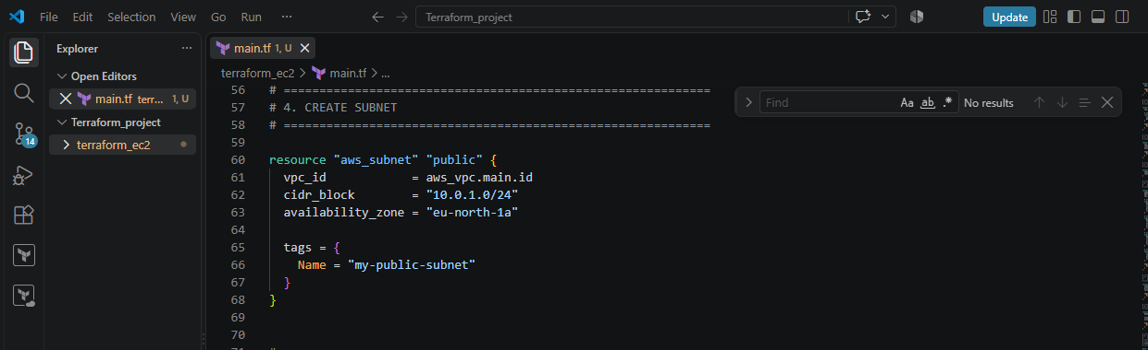
A subnet is a smaller network inside your VPC.
Your VPC is:
10.0.0.0/16
Inside that VPC, you're creating:
10.0.1.0/24
Think:
VPC
10.0.0.0/16
|
+------ Subnet
10.0.1.0/24
You're also specifying:
availability_zone = "eu-north-1a"
So this subnet is created in:
eu-north-1a

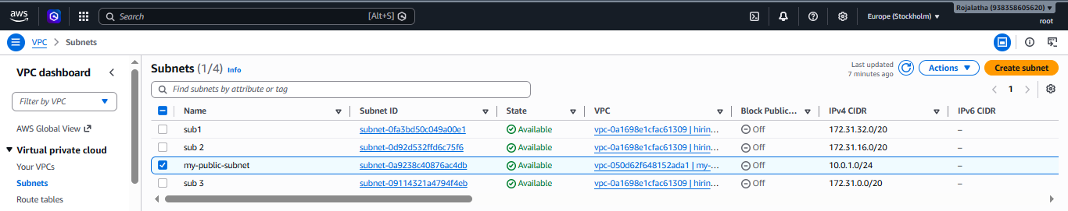
Step 6: Associate Subnet with Route Table
As created the subnet and route table separately.
Now we have to connect them:
resource "aws_route_table_association" "public" {
subnet_id = aws_subnet.public.id
route_table_id = aws_route_table.public.id
}

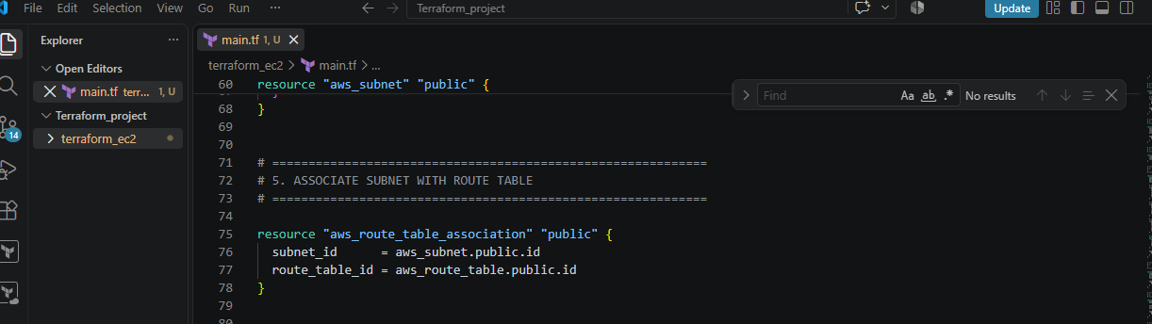
Think:
Subnet
|
↓
Route Table
|
↓
Internet Gateway
|
↓
Internet
Without this association, the subnet would not use this particular route table.
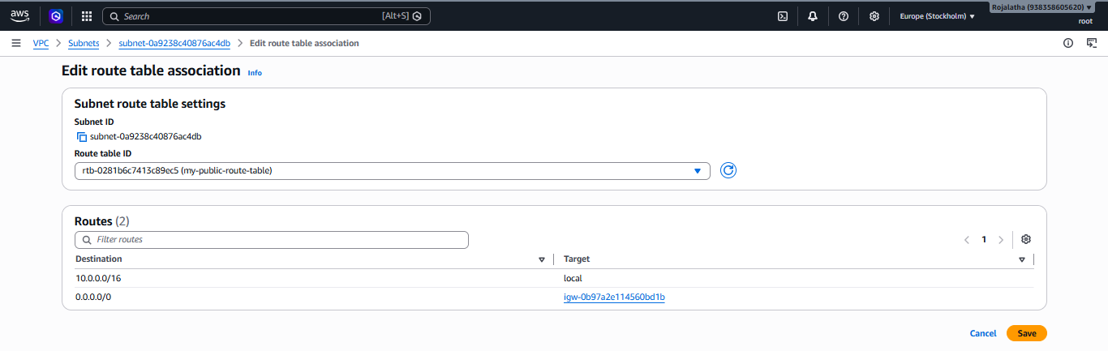
Step 7: Security Group
Code creates:
resource "aws_security_group" "web_sg"

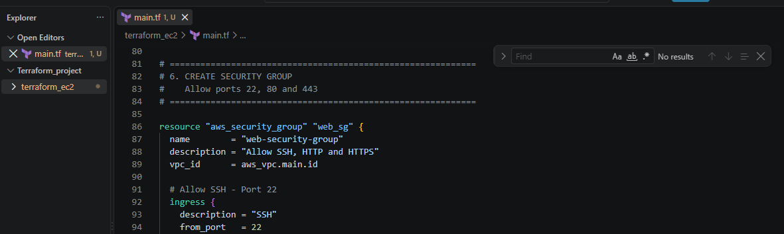
A Security Group acts like a virtual firewall for your EC2/network interface.
You allow:
Port 22 → SSH
Port 80 → HTTP
Port 443 → HTTPS
For example:
ingress {
description = "HTTP"
from_port = 80
to_port = 80
protocol = "tcp"
cidr_blocks = ["0.0.0.0/0"]
}
This means:
Allow TCP traffic on port 80 from anywhere.
So:
Internet
|
| Port 80
↓
Security Group
|
↓
EC2
Three inbound rules
Port | Purpose
22 | SSH
80 | HTTP / Apache
443 | HTTPS
You also have:
egress {
from_port = 0
to_port = 0
protocol = "-1"
cidr_blocks = ["0.0.0.0/0"]
}
This allows the server to make outbound connections to anywhere.
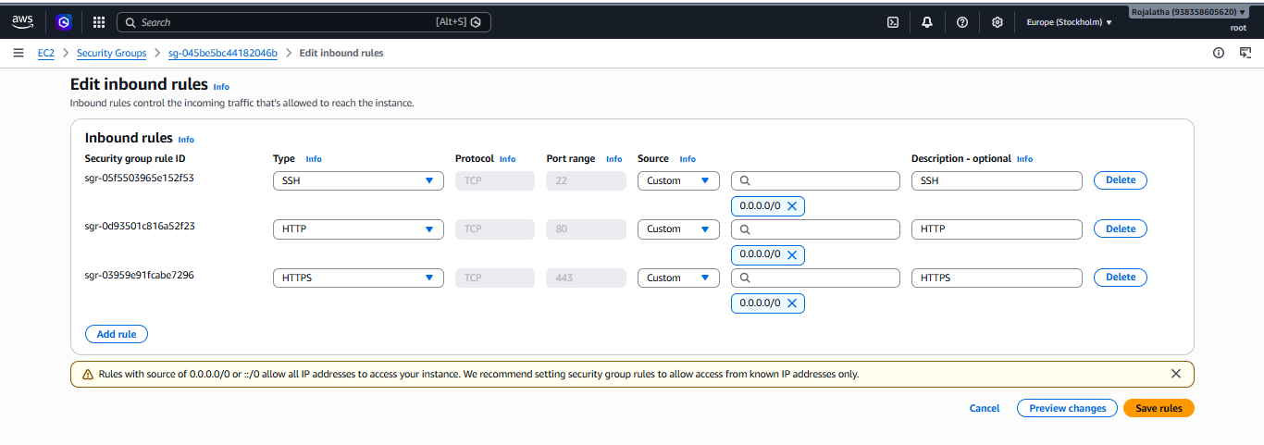

Step 8: Network Interface
Create an ENI:
resource "aws_network_interface" "web_eni" {
subnet_id = aws_subnet.public.id
private_ips = ["10.0.1.10"]
security_groups = [aws_security_group.web_sg.id]
}

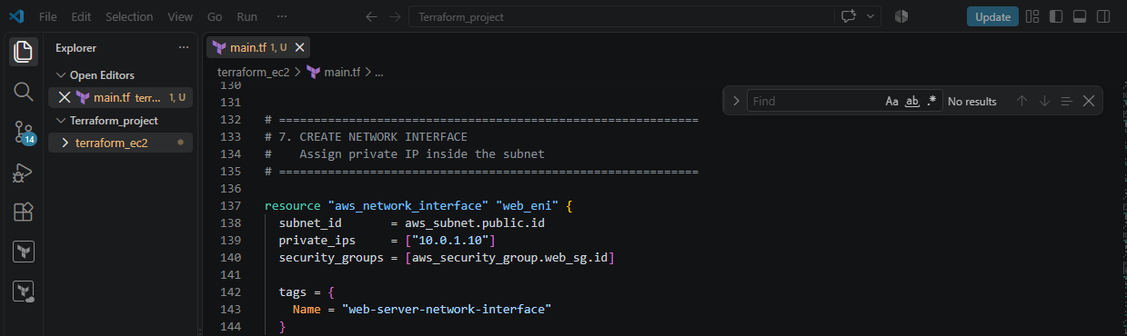
ENI = Elastic Network Interface
Think of it as the network card of the EC2 server.
It gets:
Private IP:
10.0.1.10
And it is placed inside: 10.0.1.0/24 subnet
It also uses your security group.
So:
EC2
|
↓
Network Interface
|
├── Private IP: 10.0.1.10
|
└── Security Group
├── 22
├── 80
└── 443
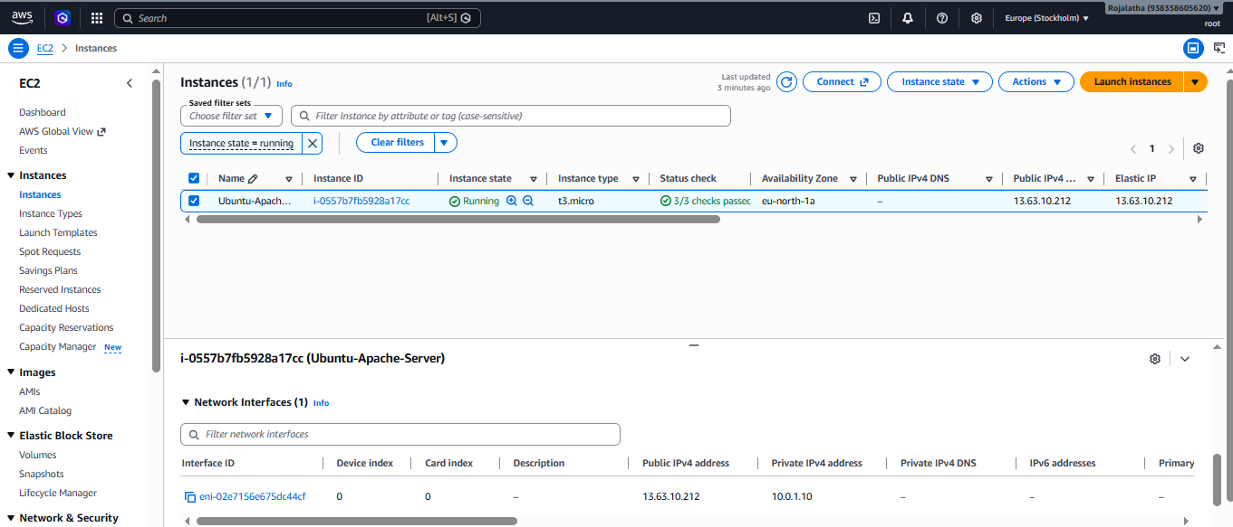
Step 9: Elastic IP
Create:
resource "aws_eip" "web_eip" {
domain = "vpc"

network_interface = aws_network_interface.web_eni.id
associate_with_private_ip = "10.0.1.10"
}

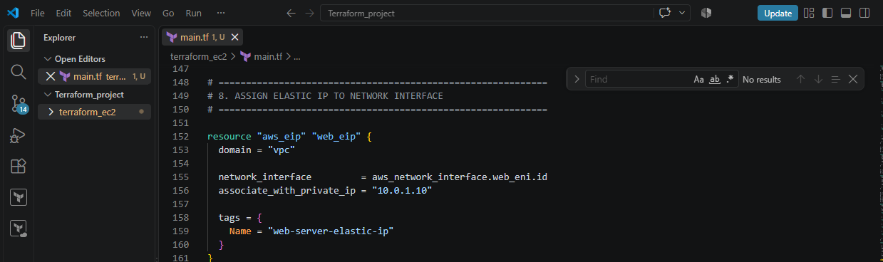
An Elastic IP is a public IPv4 address.
Our server has:
Private IP
10.0.1.10
The Elastic IP gives it a:
Public IP
So conceptually:
Internet
|
↓
Elastic IP
|
↓
10.0.1.10
|
↓
Network Interface
|
↓
EC2
This allows you to access Apache from the internet.
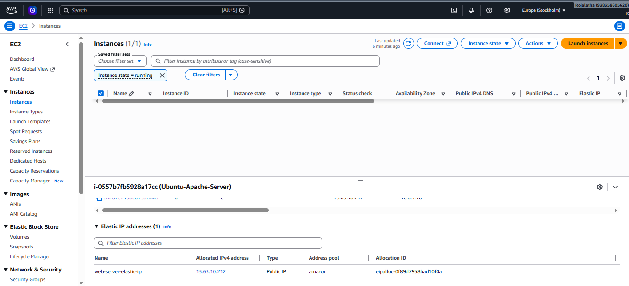

Step 10: Find the Ubuntu AMI
This part:
data "aws_ami" "ubuntu" {
is different from a resource.
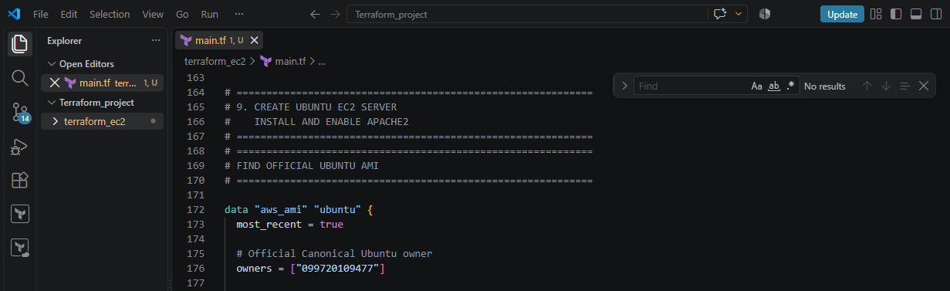
We are not creating an AMI.
We're asking AWS to find a suitable Ubuntu AMI.
Then Execute Terraform init and Terraform apply:
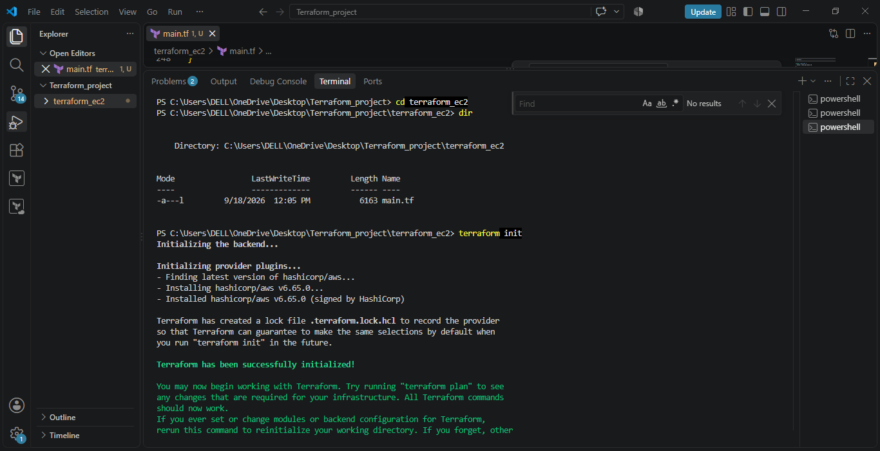
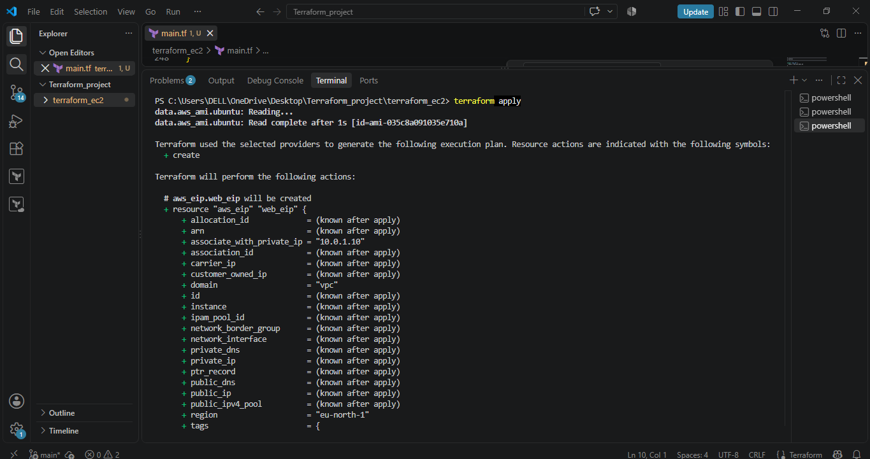
Step 11: Create EC2
Now the actual EC2 server:
resource "aws_instance" "web_server" {
You specify:
ami = data.aws_ami.ubuntu.id
This means:
Use the Ubuntu AMI that we found above.
Then:
instance_type = "t3.micro"
means:
Create a t3.micro EC2 instance.
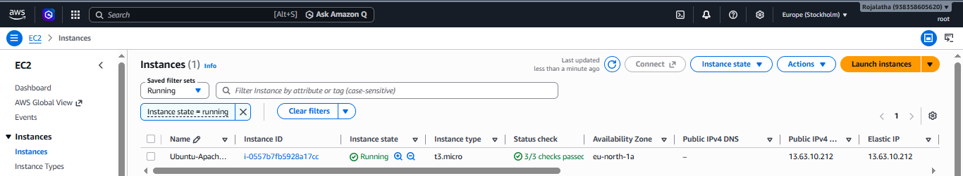
Step 12: Key Pair
We have:
key_name = "Euo.S"
This tells AWS which existing EC2 key pair should be associated with the instance.
Important distinction:
key_name
↓
AWS EC2 Key Pair NAME
It is not the .pem filename.
So if AWS Console shows the key pair name as:
Euo.S
then:
key_name = "Euo.S"
is correct.
If the actual key pair name is different, change it to the exact AWS key-pair name.

Step 13: Attach the Network Interface to EC2
Code:
network_interface {
network_interface_id = aws_network_interface.web_eni.id
device_index = 0
}
This tells Terraform:
Use the ENI I created earlier as the primary network interface of this EC2 instance.
So now:
EC2
|
↓
ENI
|
├── 10.0.1.10
├── Security Group
└── Elastic IP

Step 14: User Data
This is one of the most useful parts.
We have:
user_data = <<-EOF
#!/bin/bash

apt-get update -y

apt-get install -y apache2

systemctl enable apache2

systemctl start apache2

echo "Hello from Terraform Ubuntu Apache Server" > /var/www/html/index.html
EOF
This is a startup script.
When the EC2 instance starts, Ubuntu executes this script.
Step 1
apt-get update -y
Updates the Ubuntu package information.
Step 2
apt-get install -y apache2
Installs Apache.
Step 3
systemctl enable apache2
Makes Apache start automatically when the server boots.
Step 4
systemctl start apache2
Starts Apache immediately.
Step 5
echo "Hello from Terraform Ubuntu Apache Server" > /var/www/html/index.html
Creates the web page.
When you visit:
http://<Elastic-IP>
Apache should return:
Hello from Terraform Ubuntu Apache Server

Step 15: Outputs
At the end we have:
output "vpc_id" {
value = aws_vpc.main.id
}
Terraform will display the VPC ID after terraform apply.
Similarly:
output "subnet_id"
displays the subnet ID.
output "network_interface_id"
displays the ENI ID.
output "private_ip"
displays:
10.0.1.10
And:
output "elastic_ip"
displays the public IP.
Finally:
output "instance_id"
displays the EC2 instance ID.

